

**ÇANKAYA UNIVERSITY**

**CENG 407- ME 407-EE 407**

**UNMANNED AERIAL VEHICLE**

**(UAV)**

**PROJECT REPORT**

*Can Ateş*

*201911405*

*Yazgı Kavukçu*

*201811041*

*Doruk Kurt*

*201826045*

*Eyüp Gözükara*

*201715021*

Advisor: *Asst. Prof. Dr. Murat Saran*

Co-Advisor: *Dr. Samet Akar*

Co-Advisor: *Dr. Oğuzhan Çifdalöz*

**1. INTRODUCTION**

**About Us**

The project aims to design and program an unmanned aerial vehicle to perform some tasks automatically. It will decide and perform actions itself. We will approach this task from 3 different angles; Mechanical, Electrical, and Software. This project covers all the necessary approaches to build a drone completely. Our team consists of three different departments; computer engineering, mechanical engineering and, electrical and electronics engineering. We are all third-grade or fourth-grade students.

**Motivation**

We all wanted to enter competitions about an unmanned aerial vehicle and decided to design a complete UAV as our project. Instead of a single department, our group contains three different departments it will be our first real multi-department project experience. We are all highly motivated because we each love designing and creating and most importantly robotics.

**Problem Statement**

Our drone will be task-driven. We divided each task and they will be handled individually. The first task is the autonomous take-off and then learning and creating a digital map of the task track, our drone first flies through an empty track and learns and records the target and tools locations separately. For example, if the task is put out of the fire, the target will be the location of the fire and the tool will be the location of water. Secondly, after learning locations drones will start doing missions and their requirements. For example, in the previous example, this task will be first going to the location of water and take some water to the fire location and beginning to extinguish process. Lastly, after the mission is completed the task is to return to the start location and autonomously land.

**2. REQUIREMENTS SPESIFICATION**

**2.1 SOFTWARE REQUIREMENTS SPECIFICATION**

**2.1.1 Image Processing And Flight Control Software**

A single-board computer with a minimum of 2 GHz or faster processor speed and a minimum of 4 Gb of ram is needed for the necessary transaction speed so that drone can decide and process the data at the same time.

A flight control card will be used for all the information gathering needed for the main program to decide what is the next move that drones do and do not. So flight control card has to have the necessary sensors. Lastly a camera is needed for video input and one other camera is needed for visual presentation of flight.

**2.1.2 Operating Systems**

In raspberry pie, we will use Linux based operating system. And for autopilot software, we will use ArduPilot or ROS(Robot Operating System) these are works best with raspberry-pie and Emlid-Navio flight card.

**2.1.3 Realtime Telemetry Flight Parameters**

We will need real-time information software on our computers or smartphones so that we will keep track of our drone's real-time information like UAV range, height, speed, GNSS strength, remaining battery power, and warnings. We will use Ardu-Pilot for that.

**2.1.4 Mission Planer( Ardu-pilot )**

This software requires Windows 10 or newer versions. Integrated mouse , keyboard and at least 2 Gb of ram for minimal usage.

**2.2 ELECTRICAL & ELECTRONIC REQUIREMENTS SPECIFICATION**

**2.2.1 Thrust System Requirements**

**Motor**

Brushless DC motor selection will be adjusted by considering the weight of the total body and other equipment and the amount of total energy storage. The so-called KV rating of the motor is representing the ratio of the motor’s unloaded rpm to the peak voltage. KV will be chosen by the drone’s weight.

980KV motor will turn around 10,000 rpm so that four of them will be carrying the drone.

**Speed Controller**

To regulate the amount of current which the motor is consumed, an **electronic speed controller (ESC)** is used. ESC provides a motor to control correctly its speed and spin direction.

The normal current provided by the ESC will be 40A.

**Power Distribution Board**

Since Quadcopter has 4 motors and 4 ESCs attached to them, a power distribution process is needed. ESC is run by a single battery pack and a single battery pack has only one DC output, i.e. one positive wire and one negative wire. Thus, it needs to be extended into 4 connection wires in order to distribute all the needed energy to the ESCs and then motors.

**2.2.2 Energy Storage Requirements**

**Battery**

The main energy source of a UAV is a **LiPo** battery. In almost every aerial application, LiPo batteries are used instead of other lithium variations. LiPo batteries have lesser weight and a high discharge ratio which gives the vehicle a higher capacity for energy usage.

**Voltage of Batteries**

Almost every industrial LiPo battery has a standard voltage value which is 3.7 V. They are generally represented by *S.*

3.7 V is represented by 1S.

Therefore, $2×(3.7V)=7.4V=2S$ and so on.

Batteries, also have *‘mAh’* value means *‘milliAmp hour’*. This value is used to measure the energy capacity of a battery.

Energy drawn by the motors will decide the amount of S.

A 3S battery will be enough to provide energy for all the drone parts.

**Flight Controller**

The brain of the drone will be chosen by some criteria which are incoming parameters from sensors, handling voltage, telecommunication parts, and other drone equipment.

In addition, control system parameters will be designed on the basis of the automated drive.

The software will be loaded into a flight control card.

**Telecommunication**

Telecommunication requirements will be chosen considering the range between receiver and transmitter. Although there is no need to interrupt the drone with a remote controller due to autopilot, still there will be a GPS antenna, receiver, and telemetry.

**Environmental Hardware**

1. **Connectors**

Most of the electrical parts of a UAV are several parts that need to be connected to the proper location. ESC, Power Distribution Board, etc. all need to be connected via a connector.

1. **Battery Charger**
2. **Multimeter**

**2.3. MECHANICAL REQUIREMENTS SPECIFICATION**

**2.3.1 3D Model Requirements**

**2.3.1.1 CAD Usage**

All components of the quadcopter will be modeled in the CAD program. Autodesk Fusion 360 will be mainly used program, but other programs also can be used. Components will be assemble together included electronic parts. Their fastening method will be properly designed.

**2.3.1.2 Dimensions and Tolerances**

The modeled parts need proper dimensions and tolerances in mechanical matter. There is no way to have exact dimension in reality. So, it should be considered that after manufacturing, do the parts fit each other or not. In 3D model session this situation should be mind and proper design should be created.

**2.3.2 Frame Strength Requirements**

**2.3.2.1 FEA Usage**

Finite Element Analysis will be used to calculate stress and strain levels on the designed parts. Since this method is a numeric and iterative solution method, mesh sensitivity analysis should be done to make sure that the data from FEA is accurate enough. Boundary conditions, mesh type and size should be selected properly, and simulation should be made in a reasonable way. FEA will be done on ANSYS.

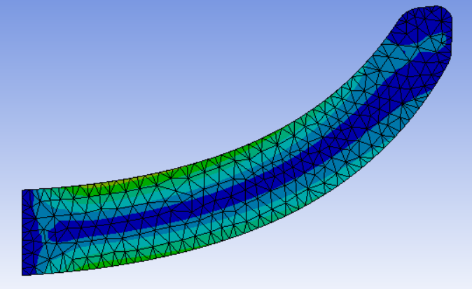

*Figure 1) Stress Distribution Example*

**2.3.2.2 Material Selection Strength Basis**

All the components have different purposes in the design so their material should be selected according to these purposes. The main parameters when selecting material are strength, mass, stiffness, vibration absorption capacity, RC wave permeability.

**2.3.3 Mass Budget Requirements**

**2.3.3.1 Total Mass Calculation**

After selecting materials of the parts, their density should be multiplied by their volumes so we can list their masses. Mechanical parts’ masses will be calculated in the design session and electronic parts masses will be taken from the catalogue data. By this way, total mass will be calculated with a reasonable margin. Maximum mass according to competition is 4kg but also the drone should be light as possible to decrease the cost of the thrust system. Also, the competition’s score sheet considers mass as a parameter that lighter drones can get higher scores.

**2.3.3.2 Topology Optimization**

Since this project is an aerial vehicle, mass should be considered properly. In a mechanical manner, generally, more mass means more strength. However, with a careful calculation, we can design a lighter but equally tough drone. By doing topology optimization, a wiser geometrical shape which distributes stress more equally can be developed. To accomplish that ANSYS will be used.

çift, alet içeren bir resim

Açıklama otomatik olarak oluşturuldu

*Figure 2) After Topology Optimization Example*

**2.3.4 Thrust System Requirements**

**2.3.4.1 Motor and Propeller Selection**

Motor and propeller selection should be done according to mass of the total system. Motor’s thrust weight ratio should be between 2 and 3 so the drone can fly properly. Motors should be attached to a convenient propeller. Greater propeller usually means greater thrust, but the efficiency of the motor can decrease after a point of this size increase.

**2.3.4.2 Vibration Elimination**

Cyclic motion of motors creates vibration. This vibration should be decreased to a certain level. So, the electronics, especially sensors, can work properly. Also, vibration have fatigue effect in mechanical manner. This fatigue can cause unexpected fracture. To eliminate vibration necessary damper elements will be used in critical points and propeller balancing operation will be done. To balance propellers, a necessary mechanism will be manufactured by using 3D printer.

cihaz içeren bir resim

Açıklama otomatik olarak oluşturuldu

*Figure 3) Propeller Balancer*

**2.3.5 Manufacturing Requirements**

**2.3.5.1 Manufacturable Design**

There are some designs which are impossible to manufacture. There is no logic on designing a part which can not be manufactured. So, manufacturability should be considered at the beginning. Also, some designs cost so much while manufacturing although there can be a way that the design is simpler but can meet the needs and it can be manufactured cheaper.

**2.3.5.2 Additive Manufacturing**

Most of the mechanical parts will be manufactured in 3D printer with proper filament. Creality Ender 3 V2 is used as printer and Cura as software. Designs should be transformed to g code to be used in 3D printer. Process parameters should be selected properly while 3D printing. This is an experimental and iterative procedure. That means many prototype parts should be printed until finding proper parameters.

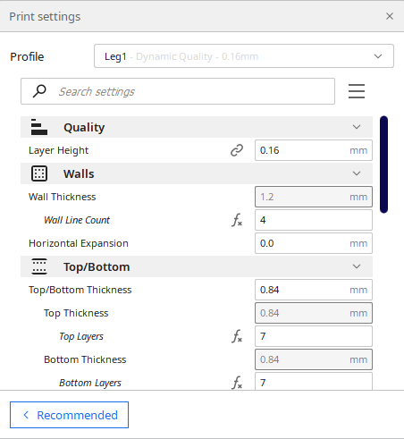

*Figure 4) 3D Printing Parameters Example*

**2.3.6 P.I.D. Control Requirements**

**2.3.6.1 Selection of Parameters**

P.I.D. Control Algorithm has three fundamental parameters which are Kp, Ki and Kd. These parameters have different effects on control of the drone. They should be iteratively changed and checked if the system works properly or not.

**2.3.6.2 Manufacturing Test Setup**

Parameters will be checked in mechanical test setups. It is not wise to create a complete drone and test it while it is flying. So, some experimental setups which simulate the drone’s flight will be manufactured.

**2.3.7 Test and Verification Requirements**

**2.3.7.1 Measurements and Fit Check**

After manufacturing 3D models, it should be tested that if the parts are in desired dimensions or not. Parts’ connections will be tested if they fit each other or not.

**2.3.7.2 Strength Test**

FEA or hand calculations are just foresight in stress, strain, and safety factor specification. So, experimental results are badly needed. Experimental setups should be created to simulate the real operating process and parts should be tested if they fracture under proper conditions or not.

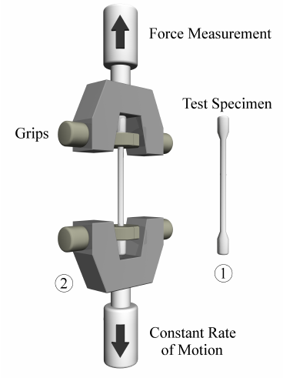

*Figure 5) Strength Test (Tensile) Example*

**2.3.7.3 Inspection**

After manufacturing, there can be some defects on the parts. These defects can degrade surface quality, strength, or they can cause crack propagation. By inspection, it will be tried to see if there are any defects or not.

**3. DESIGN DOCUMENT**

Firstly we desing our desing life cycle and it is as below

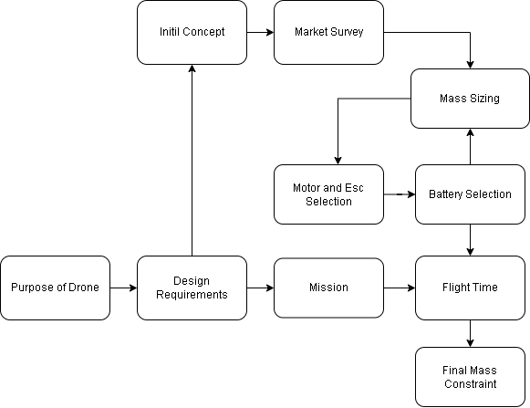

Our mission design as below chart.

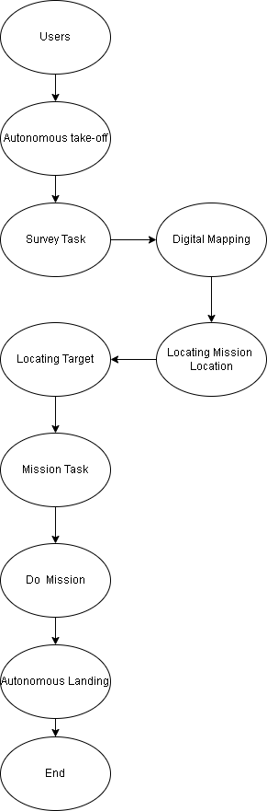

**3.1 MECHANICAL DESIGN DOCUMENT**

**3.1.1 Conceptual Design**

**3.1.1.1 Reference Design**

There are many types of drone frames. According to competition requirements, a quadcopter having less then 4kg mass will be designed. Based on this requirement as a reference design S-500 frame is selected. Its size is 50cm which means that distance from the edge of one arm to the edge of across arm is 50cm.

Reference Design

In this frame generally carbon fiber chassis, arms and legs are used. So, the stress level can be relatively higher than a plastic frame. Cross sectional area of arms should be increased if we want to design a plastic frame. Moreover, legs have a concave structure, but a convex structure will be safer for landing. The chassis have mass reduction spaces, different fastening holes or rails, etc. This type of properties should be specific to the design according to its electronical layout.

**3.1.1.2 New Design**

New Design

Exploded View

**3.1.1.3 Overview**

Many changes are done on reference design and at the end a distinctive design is appeared. In this design, arms are improved until stress level decrease to a certain level. Convex legs are designed from beginning. Chassis and the protective parts of the electronics are created according to the electronics which are chosen. Electronics mounting methods are considered.

1. **Arm Design**

Reference Arm

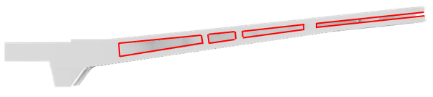

New Arm

The cross-sectional area of the arm is increased to increase second moment of area. While doing this, to avoid highly increase in mass red areas in the figure are evacuated. As a result, in certain conditions, mass didn’t increase as much as stress level is decreased.

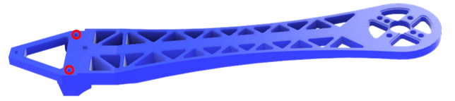

Reference Arm

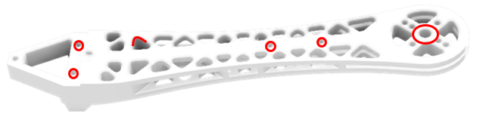

New Arm

In S500 Arm the holes that are used for connection to chassis by using screws were not thru holes and it is a condition that weaken the integrity of the frame. Hence, these holes are designed again as thru holes.

Inside cavities has fillets on their edges. In S500 fillet radiuses were not enough to dissipate the stress concentration at those points. Thus, fillet radiuses are increased in new design.

S500 design have Leg connections right under the chassis. To get more wide distances between connection points where the legs touch to the ground, leg connections are carried to the arms, and we get advantage of arms improved strength on this situation.

At the motor base of arm where the motor is fastened, inside hole’s wall thickness is increased because while printing the arms, printing done on space, so it couldn’t be completed. However, new design could deal with this problem. Also, strength is increased at that section.

Blind Hole Thru Hole

1. **Leg Design**

Reference Leg New Leg

Mass of the reference leg is nearly equal to the new leg. However, the size and orientation of the leg has been changed. Small size provided more strong structure and convex structure instead of concave structure provided more stable landing capability because of the distance between one leg to the other.

**Design Stages**

According to FEA results and topology optimization leg is designed stage by stage as shown.

**3.1.2 Strength Calculations**

**3.1.1.1 Arm**

Under the certain boundary conditions the maximum equivalent von mises stress of reference arm is equal to 25.7MPa. The yield strength of the PLA filament around 50MPa in the market. According to these data factor of safety F.S.= 1.9.

Mass of reference arm under certain printing conditions without supports is 33g.

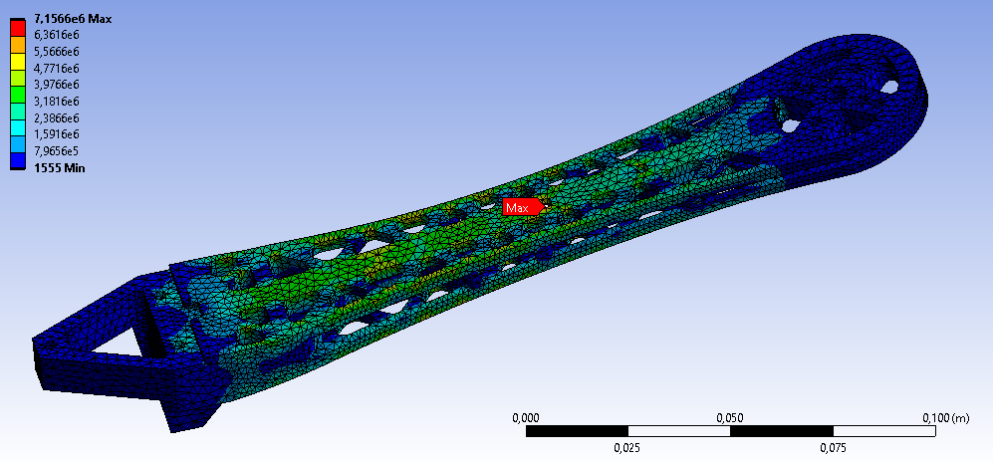

Under the certain boundary conditions the maximum equivalent von mises stress of new arm is equal to 7.1MPa. The yield strength of the PLA filament around 50MPa in the market. According to these data factor of safety F.S.= 7.

Mass of reference arm under certain printing conditions without supports is 46g.

As a result, we can see that F.S. of the arm is increase from 1.9 to 7 which means 268% improvement. At this time the mass is increased from 33g to just 46g which means an only 39% increase.

**3.1.1.2 Leg**

While designing a leg, first a coarse design is created. Under certain boundary conditions this designs’ equivalent stress level is 29MPa. Thus, the factor of safety F.S. = 1.7.

At final design we have mass reduction spaces but also, we have more strong and wide connection area. According to data shown the stress under certain conditions is 28MPa and the factor of safety F.S. = 1.8.

So, we can see that factor of safety is nearly equal and the mass is slightly changed. However, we gained a wide and strong connection area.

**3.1.2 Topology Optimization**

Topology analysis has done on the coarse leg design and the mass of the leg is decreased by trimming the unnecessary mass from the 3D model. By this way we gained the ability of improving connection edge of the leg to the arm by adding extra mass on the structure.

**3.1.3 Mass Estimation**

|  |  |  |  |
| --- | --- | --- | --- |
| **Component** | **Number of Pieces** | **Unit Mass (g)** | **Total Mass of the Component (g)** |
| Arm | 4 | 46 | 184 |
| Leg | 4 | 14 | 56 |
| Bottom Chassis | 1 | 53 | 53 |
| Upper Chassis | 1 | 34 | 34 |
| Battery Protection | 1 | 69 | 69 |
| FC Protection | 1 | 33 | 33 |
| Brushless DC Motor | 4 | 56 | 224 |
| Battery | 1 | 379 | 379 |
| ESC | 4 | 28 | 112 |
| FC | 1 | 80 | 80 |
| GPS Antenna | 1 | 30 | 30 |
| PDB | 1 | 11 | 11 |
| Propeller | 4 | 18 | 72 |
|  |  |  | **Total Mass of Drone (g)** |
|  |  |  | 1337 |

We are calculating the total mass of known components as 1337g. With a margin of 163g because of the uncertainties and unknown masses of some components. We are estimating the total mass of the drone around 1.5kg.

**3.1.4 Thrust System Design**

According to mass estimated and components selected, thrust calculations are done in the web site: <https://www.ecalc.ch/xcoptercalc.php>.

**Inputs:**

**Outputs:**

Battery Discharge Flight Time (min) Electrical Power (W)

Estimated Temperature Thrust Weight Ratio Thrust Power Ratio (g/W)

We can see that all the parameters which are important for a drone design are in the green areas except flight time but also flight time is close enough to the green area and 13.1 minute is enough to complete a mission in the competition of TEKNOFEST.

**3.1.5 Prototype Production**

1. **Arm Production**

As a result of many attempts on 3D Printing Arm and Leg components of the drone, optimum 3D Printing settings are found as shown.

The arm is printed in this orientation because other orientations caused difficult support cleaning and low surface quality. In this orientation there are places where the printer is printing to the space but the distances between walls of the structure are not too much in this orientation. So the printer is capable to print the model nearly perfect.

**Fail Printings Because of the Wrong Orientation and Setting:**

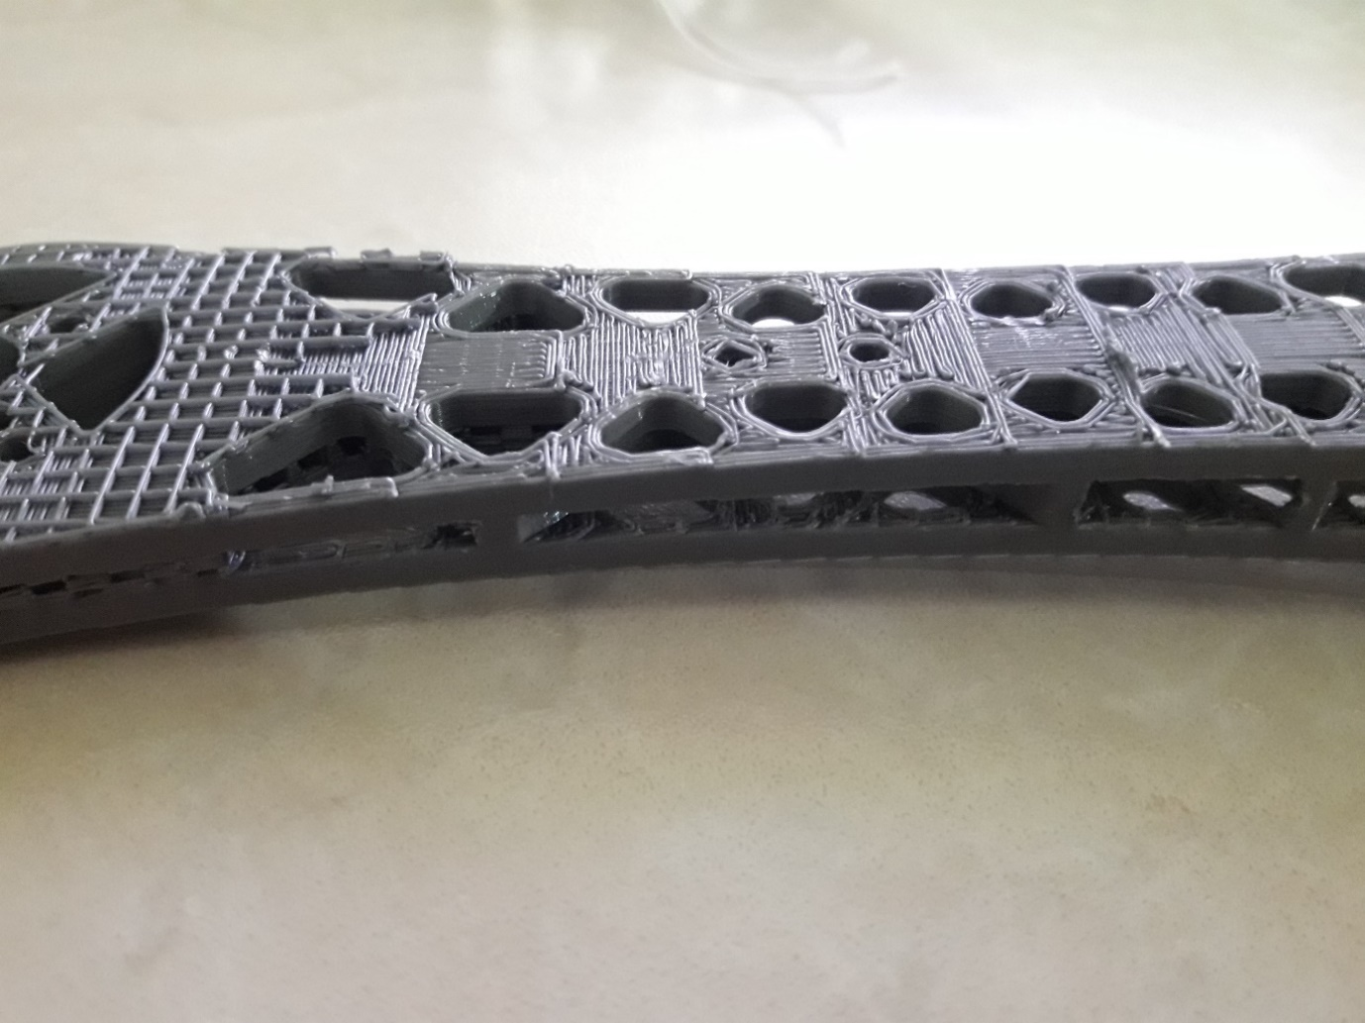

Support cleaning was a big problem because the arm is printed as top surface at the bottom. Also, cleaning support from inside cavities was so difficult. As a result, surface quality is degraded.

In this error, inside holes’ wall was so thin, so printer couldn’t accomplish the mission.

**Successful Printing:**

The surface quality is satisfaction. Only the one side of the arm has support residue, but it can be cleaned easily by using emery. Also, there is no support residue inside the cavities.

1. **Leg Production:**

**

Printed Leg Printing Orientation

Leg production was simpler than the arm production because of simpler geometry and not needing supports. Printer settings are same with arm, only difference was support setting was closed. Surface quality is satisfaction.

1. **Propeller Balancer Production:**

Since the propeller balancers in the market are expensive and the mechanism can be modeled and printed easily. We did our own propeller balancer.

Reference Propeller Balancer Our Propeller Balancer

**3.2 SOFTWARE DESIGN DOCUMENT**

Firstly Pi-Camera gathers images while the drone flies, and they are transported to raspberry pie to process. Image processing software searches for mission elements such as targets and tools. If it founds it stores their locations. And after the mapping process drone will go to their locations and perform tasks expectedly. Raspberry pi is the brain of a drone and makes decisions according to the image process and gives orders to the flight computer. The flight controller takes variables from sensors and adjusts motors accordingly.

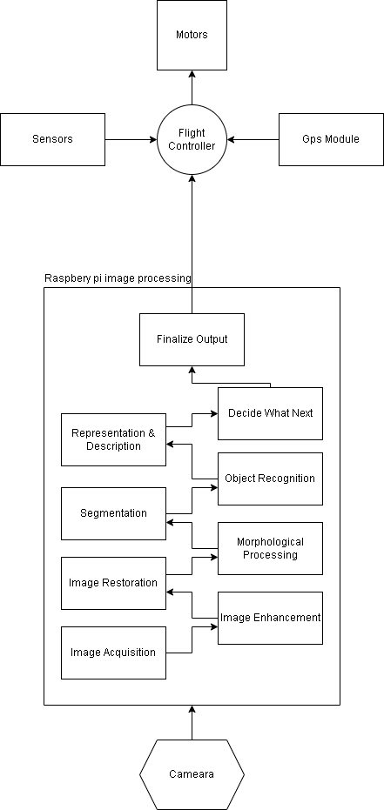

# **3.3 Electrical & Electronics Design Document**

## Connecting, Soldering and Installing Electronic Components

Required components are prepared for connection, soldering and installing to the mother board.

* 1. Connecting Motors To The Arm
  2. Soldering Motors to the ESC
  3. Soldering ESCs to the PDB
  4. Connecting ESC’s Signal Cable to the Flight Control
  5. Installing Battery
  6. Connecting Power Module with Battery & Connecting Signal Cable to the Flight Control Card
  7. Connecting GPS Module, Telemetry and Receiver to the Flight Control Card

1. Electrical Specification of All Components
   1. 3-Phase motor is coupled mechanically to the propellers.
   2. ESCs have output of 5V/3A and power the 3-Phase motors.
   3. PDB is connected to the Power Module’s 5.3 pinouts and Power module’s signal cable is connected to the Flight Control Card.
   4. Battery have output of 11.1V and connected to the Power Module.
   5. All ESCs are connected to the Flight Control Card’s 5V pinouts.
   6. 2.4 GHz / 12 Channel Receiver is connected to the Flight Control Card.
   7. All additional external components are connected to the 5V pinouts.

Figure 1 UAV Electronics Block Diagram

**4. CONCLUSION & DISCUSSION**

Firstly we decided what type of unmanned aerial vehicle we are going to produce. After the research process, we decided to create a quadcopter (X4 configuration multi rotor). Then we head towards researching the working principles of a quadcopter. We select and research all the necessary electronic and mechanical parts with all the necessary calculations about price, mass budget, power consumption, thrust weight ratio, and flight time in our minds. We design the 3D model of our drone with all the parts intact. Moreover, the frame of the drone is completely designed by our team. Most of the necessary stress simulations of our mechanical parts are done. Some prototype parts of our drone frame are printed by a 3D printer, and they fulfill all the requirements and surface quality expectations. Necessary courses about image processing and autopilot software have been bought and we start to watch them. In the Software Engineering department at Robotics Community, there was an old Unmanned Aerial Vehicle project designed and produced. We took the old parts and we are going to use some of them to produce our prototype while we are learning. We mostly discuss the parts that we are going to need, and we conclude this with the help of a technician of our school and our teachers. After all discussion, we decided on our equipment list as we listed below.

|  |  |  |  |  |  |
| --- | --- | --- | --- | --- | --- |
| **İsim** | **Model** | **Adet** | **Adet Fiyat (TL)** | **Link** | **Fiyat (TL)** |
| Fırçasız Elektrik Motoru | SUNNYSKY A2212-980KV CCW | 3 | 167,53 | [shorturl.at/dnCDM](http://shorturl.at/dnCDM) | 502,59 |
| Fırçasız Elektrik Motoru | SUNNYSKY A2212-980KV CW | 3 | 167,53 | [shorturl.at/lotS0](https://www.robotistan.com/sunnysky-a2212-980kv-outrunner-fircasiz-motor-kendinden-kilitli-vida-cw?language=tr&h=37653a14&gclid=Cj0KCQiAys2MBhDOARIsAFf1D1c7ovZa-douriYUCJTcReQ2ZszxqRXP8HAxmnvTM0wkk-VLRaY85egaAl49EALw_wcB) | 502,59 |
| Drone Frame + İniş Takımı | F450 | 1 | 158,92 | [shorturl.at/jtATU](https://www.robotistan.com/f450-kit-with-skid-landing) | 158,92 |
| Batarya Kılıfı | Lipo Pil Koruma | 1 | 42,9 | [shorturl.at/corJS](https://www.robotekno.com/lipo-pil-koruma-kilifi) | 42,9 |
| Batarya Şarj Cihazı | Imax B6 Şarj Cihazı + Şarj Adaptörü | 1 | 384,9 | [shorturl.at/gFLZ4](https://www.hepsiburada.com/imax-b6-sarj-cihazi-sarj-adaptoru-p-HBV00000R42YG?magaza=candagrup&ds_rl=1294343&wt_gl=cpc.6824.shop.nelk.hobi&isFashion=true&ds_rl=1294343&gclid=CjwKCAiAp8iMBhAqEiwAJb94z_f857XxgeB2K1xDjIqgPqsSDmSglnLHrJtEyNP_K_nc_fRig-bemBoCd5gQAvD_BwE&gclsrc=aw.ds) | 384,9 |
| Li-Po Batarya | 11.1V 5200mAH 3S 40C Leopard | 2 | 637,91 | [shorturl.at/vLR29](https://www.f1depo.com/urun/3s-5200mah-30c-lipo-batarya-11-1v-pil?gclid=CjwKCAiAp8iMBhAqEiwAJb94zwB69qior6mWqmSHc7AVscDytd4BwEkPdu21zpZhpq9Kk6iC4e7qSxoCzbsQAvD_BwE) | 1275,82 |
| ESC | 40A ESC Skywalker | 6 | 216,86 | [shorturl.at/hmqEH](https://www.direnc.net/skywalker-40a-esc-fircasiz-motor-hiz-kontrol-surucu-devresi?language=tr&h=a76b050f) | 1301,16 |
| Raspberry Pi 4 | Raspberry Pi 4 | 1 | 1599 | [shorturl.at/girHO](https://www.amazon.com.tr/Raspberry-Pi-ARM-Cortex-A72-Bluetooth-Micro-HDMI/dp/B07TC2BK1X/ref=asc_df_B07TC2BK1X/?tag=trshpngglede-21&linkCode=df0&hvadid=510650276634&hvpos=&hvnetw=g&hvrand=15827794755743136582&hvpone=&hvptwo=&hvqmt=&hvdev=c&hvdvcmdl=&hvlocint=&hvlocphy=1012763&hvtargid=pla-818643320764&psc=1) | 1599 |
| Uçuş Kontrol Kartı | Emlid Navio 2 | 1 | 3021,71 | [shorturl.at/dgtKR](https://www.robotistan.com/navio-2-ucus-kontrol-karti-seti-navio-2-kablo-seti-gps-anteni-emlid-navio-guc-modulu) | 3021,71 |
| GPS Anteni | - | 1 | 0 | **Included in the Flight Controller** | 0 |
| Güç Modülü | - | 1 | 0 | **Included in the Flight Controller** | 0 |
| Receiver |  | 1 | 758 | [frsky-l9r-alici](https://www.dronmarket.com/urun/frsky-l9r-alici) |  |
| Drone Güç Dağıtım Panosu | F18057/8 | 1 | 172,04 | [shorturl.at/fxBHV](https://www.direnc.net/f180578-drone-guc-dagitim-panosu) | 172,04 |
| Pervane | Dji 1045 (CCW + CW) | 4 | 32,34 | [shorturl.at/bqNS7](https://www.f1depo.com/urun/dji-1045-pervane-seti-ccw-ve-cw-10-inc) | 129,36 |
| Kumanda | Radiolink AT9S Kumanda 2.4ghz 9 Kanal | 1 | 1456,36 | [shorturl.at/bsCF9](https://www.f1depo.com/urun/radiolink-at9s-kumanda-2-4ghz-9-kanal-alici-verici-1?gclid=CjwKCAiAp8iMBhAqEiwAJb94z8RkmDgRHhW84QKUC9sP1M9mZlnfxGVJ361KYc29vcFJv37leRZ_ARoCjAEQAvD_BwE) | 1456,36 |
| Kumanda Alıcısı | R9DS | 1 | 0 | **Included in the Transmitter** | 0 |
| PCB Anten | Xbee 3 pro | 2 | 590 | [shorturl.at/eoFPT](https://www.gittigidiyor.com/bilgisayar-tablet/xbee-3-pro-modulu-rp-sma-anteni_pdp_726937283?utm_source=google-pla&utm_medium=paid-search&utm_content=491091086638&utm_term=116632879376&ga_prodid=726937283&ga_merchantid=146525069&sc_gcsp=gg&gclid=Cj0KCQiAys2MBhDOARIsAFf1D1dbgpKG4vmlv_tOmJgfPL5lWL-0tczB144EN_NhIZgq4OKmpGhMQu4aAp2iEALw_wcB) | 1180 |
| Yarım Dalga Anten | 2.4 GHz 4.5 Inch Yarım Dalga RP-SMA Xbee Anten | 2 | 104,38 | [shorturl.at/mAKSY](https://www.robotistan.com/24-ghz-45-yarim-dalga-anten-a24-hasm-450) | 208,76 |
| Xbee Adapter | XBee Explorer USB | 2 | 62,05 | [shorturl.at/kBWZ9](https://www.robotistan.com/xbee-explorer-usb) | 124,1 |
| Xbee Adapter |  | 1 | 25,23 | [shorturl.at/blyzM](https://www.robotistan.com/xbee-adaptor) | 25,23 |
| Kamera | Raspberry Pi 3 ve 4 Uyumlu Kamera Modülü | 1 | 164,02 | [shorturl.at/sEGJM](https://www.robotistan.com/raspberry-pi-3-ve-4-uyumlu-kamera-modulu) | 164,02 |
| Filament | esun 1.75mm Siyah PLA+ | 1 | 156,62 | [shorturl.at/pyO49](https://www.hepsiburada.com/esun-1-75-mm-pla-filament-siyah-p-HBCV000007DDB3?magaza=savapol&ds_rl=1294343&wt_gl=cpc.6802.shop.elk.it-ssc&isFashion=true&ds_rl=1294343&gclid=CjwKCAiAv_KMBhAzEiwAs-rX1KqxuSfOSIMm3PSgiuNQ7MH-l8E5Fdb9ynlT_JFjKk8jzLIMYIYKAhoCwZkQAvD_BwE&gclsrc=aw.ds) | 156,62 |
| Filament | esun 1.75mm Beyaz PLA+ | 1 | 190,04 | [shorturl.at/elHJK](https://www.hepsiburada.com/esun-pla-beyaz-1-75-mm-3b-yazici-filament-p-HBV000002JAIZ) | 190,04 |
| LEhim Seti | Robotistan | 1 | 169,76 | [shorturl.at/lyKRS](https://www.robotistan.com/super-lehimleme-seti-1) | 169,76 |
| Kesme Matı | Çin | 1 | 9,9 | [shorturl.at/cfjlJ](https://www.robotistan.com/kesme-mati-a3-9060) | 9,9 |
| Multimetre |  | 1 | 85,43 | [shorturl.at/foBKT](https://www.robotistan.com/unit-ut-33d-dijital-multimetre) | 85,43 |
| Batarya Voltaj Test Cihazı | Ready To Sky 3.7-30V 1-8S Batarya Voltaj  Test Cihazı ve Alçak Gerilim Buzzer Alarmı | 1 | 26,25 | [shorturl.at/ghtD9](https://www.amazon.com.tr/Ready-Sky-3-7-30V-Batarya-Gerilim/dp/B092VQXBSV/ref=asc_df_B092VQXBSV/?tag=trshpngglede-21&linkCode=df0&hvadid=510376667689&hvpos=&hvnetw=g&hvrand=199031817649439559&hvpone=&hvptwo=&hvqmt=&hvdev=c&hvdvcmdl=&hvlocint=&hvlocphy=21055&hvtargid=pla-1256479396747&psc=1) | 26,25 |
| Şok Emici Damper |  | 4 | 14,3 | [shorturl.at/jzBDG](https://www.roboshop.com.tr/m3-titresim-emici-damper-disi-disi) | 57,2 |
| Çift Taraflı Bant | 3M 03614 Akrilik Ultra Güçlü Çift Taraflı Bant (1,27Cm X 4,6 M) | 2 | 40,25 | [shorturl.at/tvAGM](https://www.hepsiburada.com/3m-03614-akrilik-ultra-guclu-cift-tarafli-bant-1-27cm-x-4-6-m-p-HBV000002HNUM?magaza=Boyabu&url_src=ios-product-detail) | 80,5 |
| Banana Konnektör | Banana Gold Konnektör 3.5 mm (Erkek - Dişi) | 24 | 6,15 | [shorturl.at/ntDN5](https://www.robotsepeti.com/banana-gold-konnektor-35-mm-erkek-disi) | 147,6 |
| Xt60 Konnektör |  | 5 | 7,13 | [shorturl.at/gA025](https://www.robotsepeti.com/xt60-konnektor) | 35,65 |
|  |  |  |  |  | **13.208,41** |
|  |  |  |  |  |  |

**5. REFERENCES**

*[1] Santos, Igor & Nieves, Javier & Bringas, Pablo & Penya, Yoseba. (2010). Machine-Learning-Based Defect Prediction in High-Precision Foundry Production.*

*[2] Moaveni, S., “Finite Element Analysis, Theory and Application with ANSYS”, Prentice-Hall, 1999.*

*[3] Kalpakjian, S., &amp; Schmid, S. R. (2006). Manufacturing Engineering and Technology. Pearson Education.*

*[4]* [*https://www.dronezon.com/learn-about-drones-quadcopters/what-is-drone-technology-or-how-does-drone-technology-work/*](https://www.dronezon.com/learn-about-drones-quadcopters/what-is-drone-technology-or-how-does-drone-technology-work/)

*[5]* [*https://ardupilot.org/*](https://ardupilot.org/)

*[6]* [*https://en.wikipedia.org/wiki/Unmanned_aerial_vehicle*](https://en.wikipedia.org/wiki/Unmanned_aerial_vehicle)

*[7]* [*https://rotordronepro.com/*](https://rotordronepro.com/)

*[8]* [*https://www.getfpv.com/learn/fpv-essentials/*](https://www.getfpv.com/learn/fpv-essentials/)